Name of Centre:  Lambeth College |  |  | Learner achievement (please circle) NB: All learner achievement is provisional until confirmed at the AVA Awards Board
 |  |  | Level Achieved: |  | L2 | 3 credits
 |  |  | Final Grade Achieved  (Level 2 units only) |  | P
 |  |  | Resubmission? |  | Y | N

L2 Dip. In Skills for Further study in Health and Human Sciences

Unit title(s): Infection and Immunity |  | Unit code(s): PA1/2/LQ/031
Learner:  Group: _____ |  | Tutor/Assessor: Washington Ogwang
Description of Assignment:
Assignment 1: Worksheet of questions and practical covering assessment criteria 1.1 , 1.2, 2.1, 2.1, 3.1,3.2, 4.1,4.2, 5.1 and 5.2

All components need to be submitted in order to pass the unit.
Date set: WB 6/05/2019 |  |  |  | Date for final: WB 3/06/2019  submission:
Extension date  (if agreed): | Signed by Tutor/Assessor to agree extension: |  |  | Date  submitted:
Learner declaration:
- The explanations and evaluations in this work have been developed and written by me.
- I have not submitted material copied from the Internet, text books or other sources in place of my own thinking and writing.
- When I have referred to the work of others I have done so to discuss, comment on or argue their ideas.
- I have kept quotation and paraphrasing to an absolute minimum and only to support points I have made.
- I understand that referencing the names of authors whose ideas I have used without including my own interpretation of those ideas, does not meet the assessment criteria and cannot attract the Pass, Merit or Distinction grades.
- I have not copied the work of my peers.

Learner comments: (please use this space to comment on any aspect of the assignment when handing in your work)
Signature: |  |  | Date:

TO THE LEARNER: Please attach this assignment brief to any written work you are handing in for assessment, or submit the brief as instructed. YOUR WORK CANNOT BE ASSESSED UNLESS YOU HAVE SIGNED AND SUBMITTED THIS FORM

LEARNING OUTCOMES | ASSESSMENT CRITERIA
The learner will: | The learner can:
1. Understand the main types of pathogens and their mode of transmission | - Identify the main types of pathogen.  1.2 Describe the mode of transport of the main types of pathogens
2. Understand the non-specific defences of the body | 2.1. Describe non-specific defences of the body
3. Understand the organisation of the immune system and the immune response | 3.1. Describe the organisation of the immune system  3.2. Describe the immune response
4. Understand what is meant by acquired immunity | 4.1. Describe what is meant by acquired immunity.  4.2. Describe how vaccines work
5. Understand the role of antibiotics in treating infection. | 5.1 Describe how antibiotic works  5.2Describe how antibiotics are used to treat infection.

Title of Pre-Access OCNLR

Unit title(s): Diet and Nutrition |  |  |  |  |  |  |  | Unit code(s): PA1/2/LQ/073
Learner: |  |  |  |  |  |  |  | Tutor/Assessor: Washington Ogwang
Part A: Feedback on credit level
AC no |  | Credit achieved L2 |  | Location of evidence |  |  | Tutor/Assessor comments on assessment criteria  (you could also indicate on the work itself where each AC is met)
1.1 , 1.2 |  |  |  | Task 1a & b
2.1 |  |  |  | Task 2
3.1 ,3.2 |  |  |  | Task 3
4.1. 4.2 |  |  |  | Task 4a & b
5.1 & 5.2 |  |  |  | Task 5a & b
Level achieved |  |  |  | Tutor/Assessor’s signature: |  |  |  |  |  |  |  | Date:
Resubmission (if applicable) If any of the assessment criteria for this assignment have not been met at Level 2, a resubmission may be permitted. Resubmission must follow the QAA guidelines and be permitted only once.
Requirements for resubmission/new Task set:

Date Set: |  |  |  |  |  | Date due: |  |  |  |  | Date Submitted:
Feedback on resubmission:

Level achieved  after resubmission: |  |  |  |  | Tutor/Assessor’s signature: |  |  |  |  |  | Date:

Understand the main types of pathogens and their mode of transmission (criteria 1.1 & 1.2)

Task 1a. ( 1.1)

List the types of pathogens and state a disease caused by each of them. You might also like to refer to how the disease is controlled,
TYPE OF PATHOGEN | DISEASE | CONTROL

Task 1b.
(Criterion 1.2)

Complete the following table to show how infections can enter the body.

Infection Type | How pathogens enter the body… | Examples…
Droplet Infection


Contaminated Food and Drink
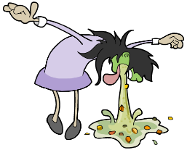

Through a break in your skin
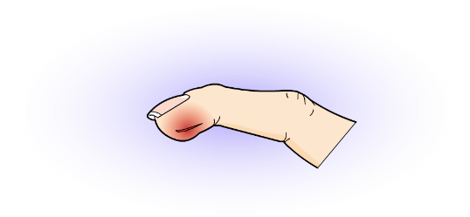

Direct Contact
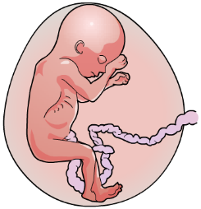

Indirect Contact
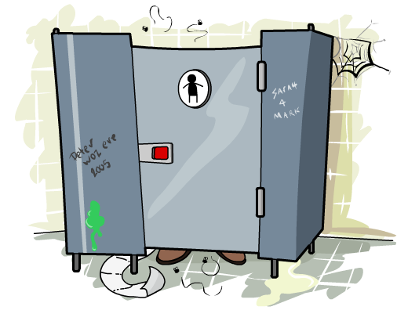

2 Understand the non-specific defences of the body (2.1)

Task 2

Tetanus is caused by bacteria called Clostridium tetani. These bacteria can survive for a long time outside the body, and are commonly found in soil and the manure of animals such as horses and cows. If they enter the body through a wound, the bacteria can quickly multiply causing symptoms such as muscle stiffness and spasms. The bacteria can cause tetanus if they get into the body through cuts and scrapes
You are to produce a Poster to show the body’s first line of defence, in other words how the body prevents the entry of Clostridium tetani bacteria and the second line of defence, when bacteria has entered the body.

- Understand the organisation of the immune system and the immune response (criteria 3.1 & 3.2)

Task 3
Produce two separate spider diagrams, one showing the organization of immune system and the second immune response

4. Understand what is meant by acquired immunity (criteria 4.1 & 4.2)

Task 4a

What are antibodies and how do they work?

Task 4b.
Produce a large, clear flow diagram to describe how vaccinations help to stop pathogens making us ill with reference to information about the immune system .

5. Understand the role of antibiotics in treating infection criteria (4.1 & 4.2.)
Task 5a

What are antibiotics and how do they work?

.

Task 5b.

All patients should be given antibiotics instead of vaccines”. Do you support this statement? Give reasons to support your answer.

